# . Sample User Manual per Module with Screen Shots & captions

## Emergency Nodes (E-Nodes)

To be able to use the E-Nodes you need all the following ready:

1. Deployment Plan - Create these according to the product specifications
2. Raspberry Pi Nodes - These should come with a microSD memory card and a 802.11 dongle.
3. Battery Packs - These are dependent on the amount of time you want the node to be up.

Figure 1. Raspberry Pi 3 Model B (With and without case)

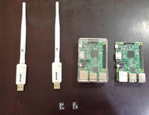

Figure 2. Components for the Node

Figure 3. Assembled Node with Battery Pack

**Formulation of the Deployment Plan**

*(The E-Nodes are connected to each other in the mesh network via the 802.11 dongle with a 3dbi antennae. With a clear line of sight, meaning there are no obstructions in between the two nodes, the effective range between two nodes is 380 meters.)*

* In order to properly provide the intended area with a good network coverage, plot the nodes on the map in such a way that the nodes are 250-300 meters from each other and each node is within line of sight of its nearest neighbor. (Note: You can design the deployment any way you want but more redundant interconnections would provide better data handling and increase reliability.)
* After plotting in the map, prepare the necessary materials to properly affix the nodes with the battery packs to the elevated area (i.e Tree / Post / Structure)
* Label the nodes properly to not mix up the deployment

**Deployment**

* Know what nodes will act as the seed of the database cluster in the network as this will be the one setup first

*(Note: This is needed only at the beginning to ensure that all nodes will be properly linked to the created database cluster. Seeds will be determined by the configuration of the technician in charge of the maintenance of the nodes)*

* For each station, starting with the seeds of the database cluster, attach the node to the battery pack via the USB charging cable, making sure that it is connected to the 2 Ampere output.*(Note: The nodes require 2A power to successfully function properly)*
* Repeat the process until all the nodes are up and running following the deployment plan created

**Accessing the network**

* Go within range of a network node's Access Point

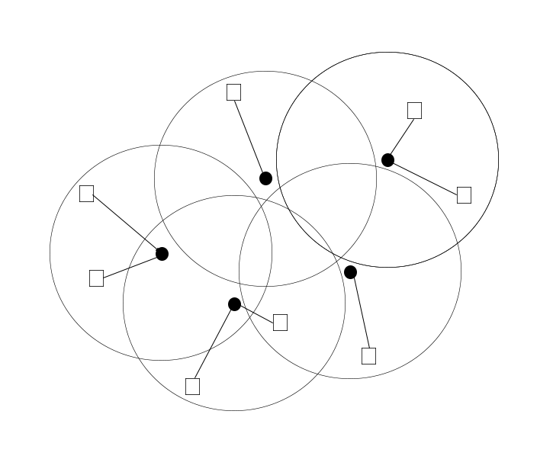

The black dots are examples of the nodes and the circles represent the access point range. The boxes represent the users that are within range of the nodes Access Point

* Use a smartphone or laptop and open Wi-Fi connections

*(NOTE: It is normal to see more than one node as we want the nodes to overlap to ensure that the signal is available all throughout the deployment area)*

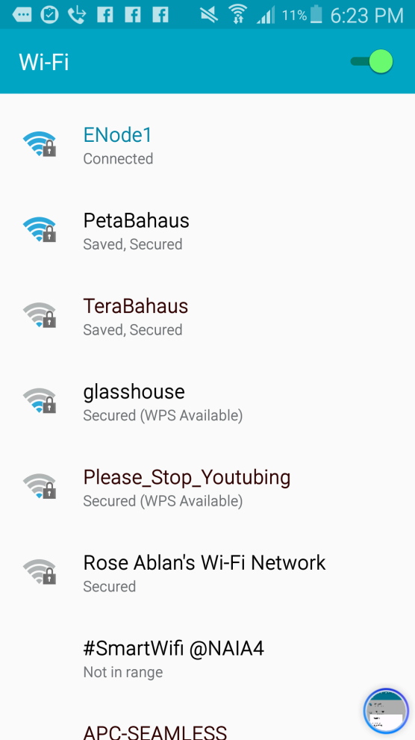

If you see the access point on your Wi-fi connections, it means you are within range

* Choose the access point nearest to you.

*(NOTE: If you don’t know what is the nearest, select the one with the strongest signal)*

* Connect to that access point with the WPA2 Passphrase

*(Note: If unchanged, default passphrase is “raspberry”)*

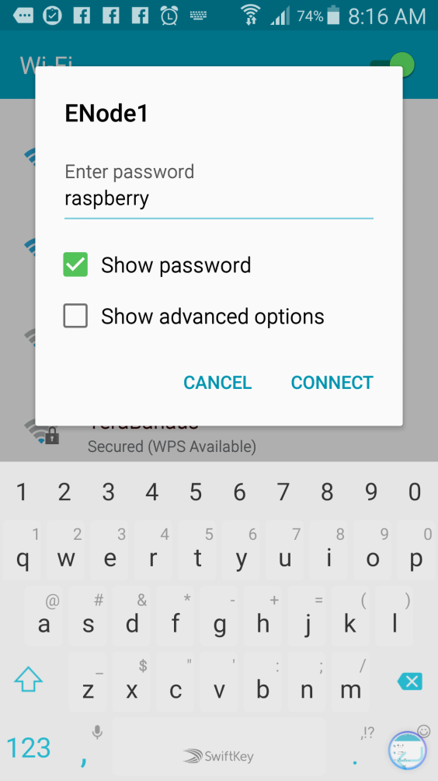

It's as simple as that! Now once you are connected to the network, you can use other applications such as Walkie-tooth to make use of the established connection.

## B. Post-Disaster Emergency Communications System v0.5

To be able to use the PDECS you need all the following ready:

1. You have to be connected to an E-Node access point
2. A web browser

### **Open the Web Browser on Your Device**

Once open, type in the url of the web service :" **http://ecc.aid "**

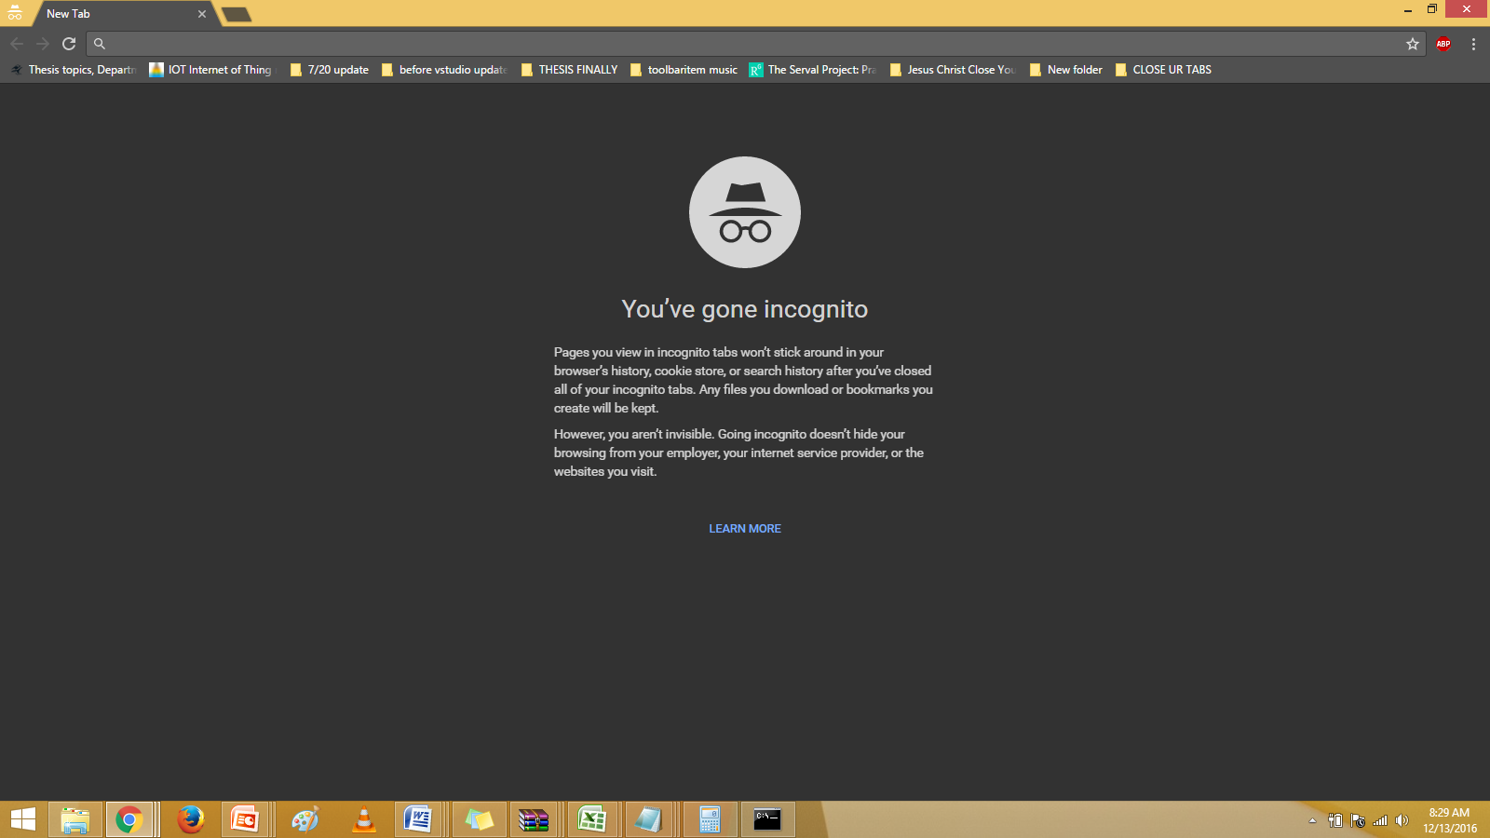

### **Login/Register**

User is redirected to the login page if not logged in. MAC address is automatically fetched.

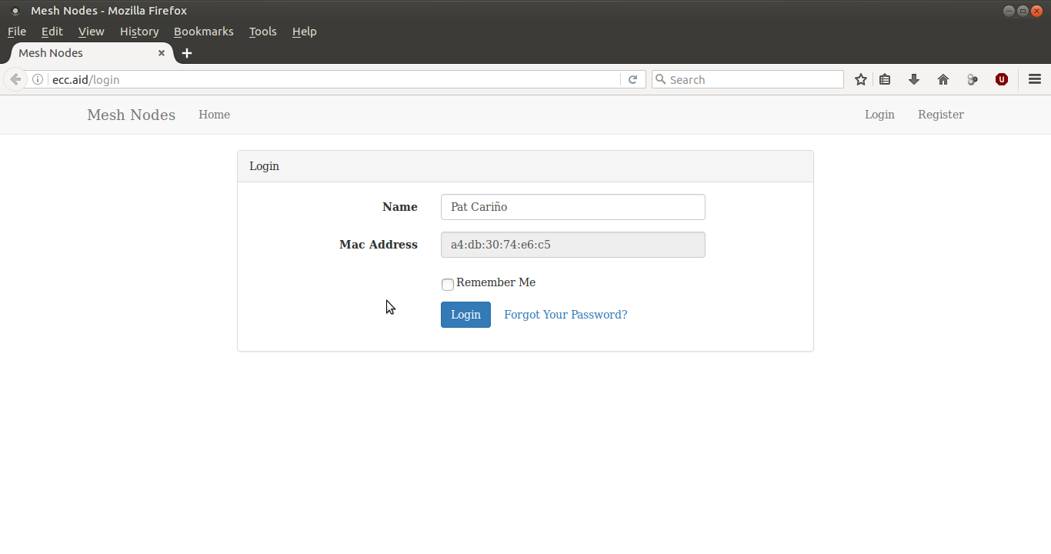

If user is not registered on the node, the details entered on the login page will be forwarded to the registration page.

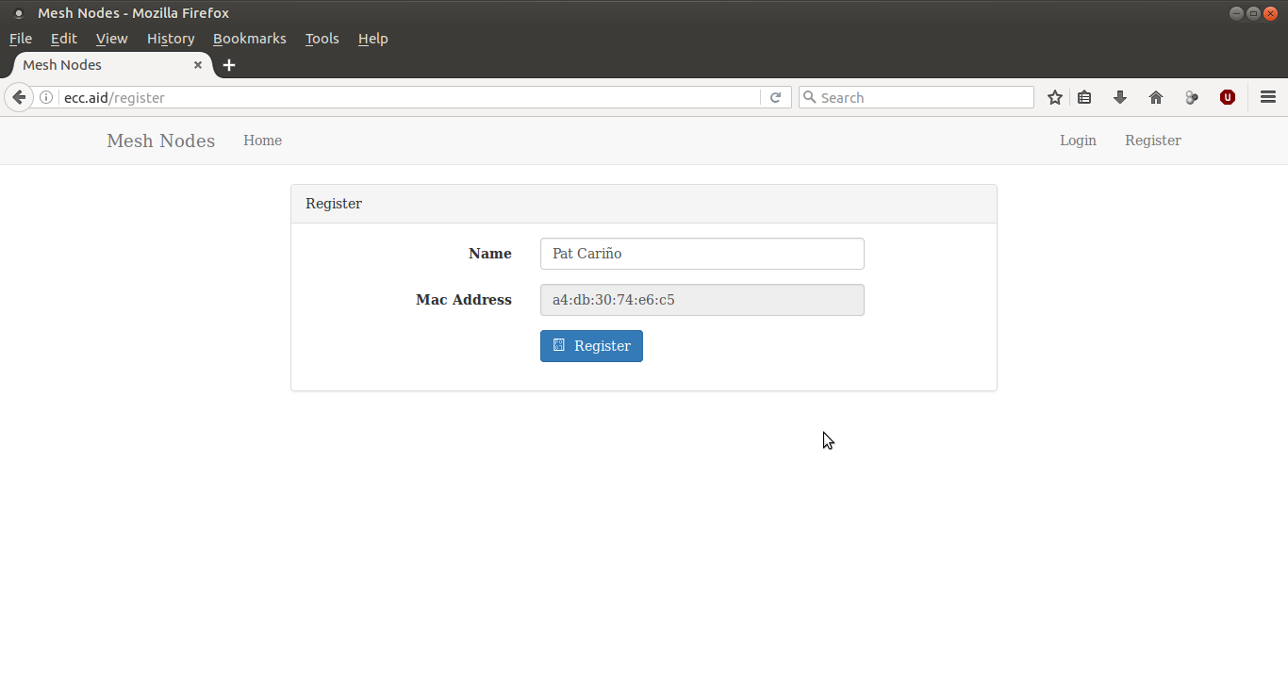

After registering or logging in, the user is directed to the home page.

### **Chat**

The homepage contains both the Chat and the Map function of PDECS

To send a chat message, simply go on the bottom of the page and press the input box. Type the message you wish to send and press the SEND button on the lower right side of the screen

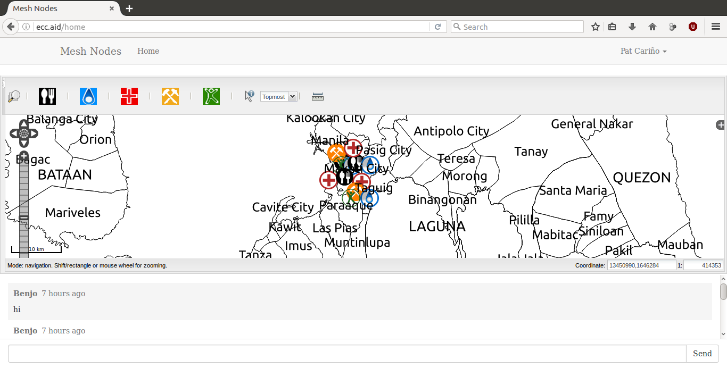

### **Map**

A user will select a marker on the toolbar. An alert will appear to indicate the selected marker.

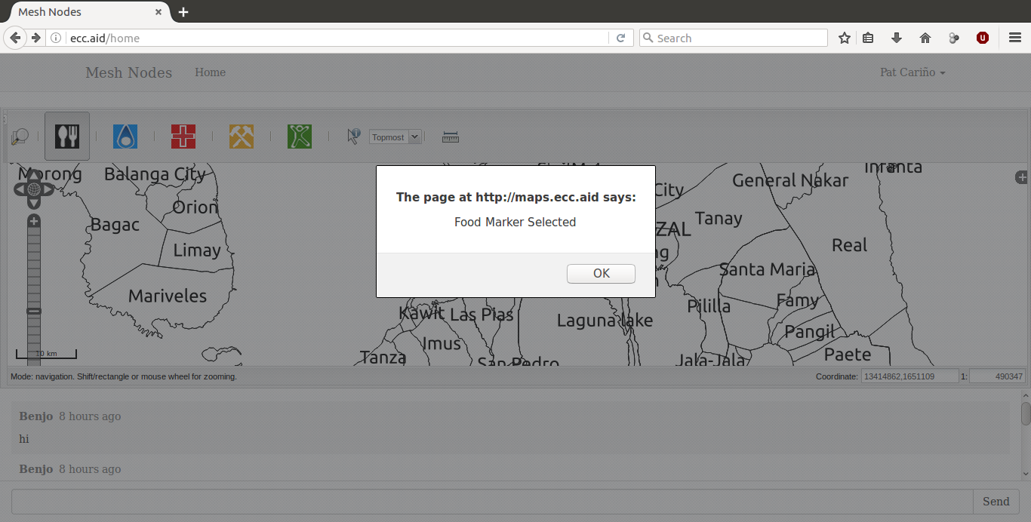

After pressing OK, the user can now tap or click on the map to place the marker.

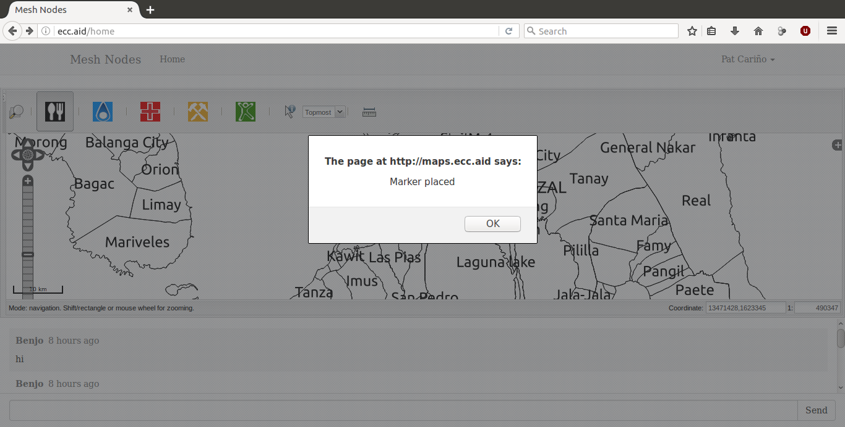

After tapping/clicking, an alert will popup to confirm that the marker has been placed